Git Assignment 3

Create Branches

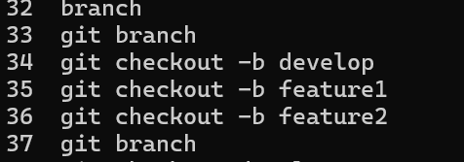

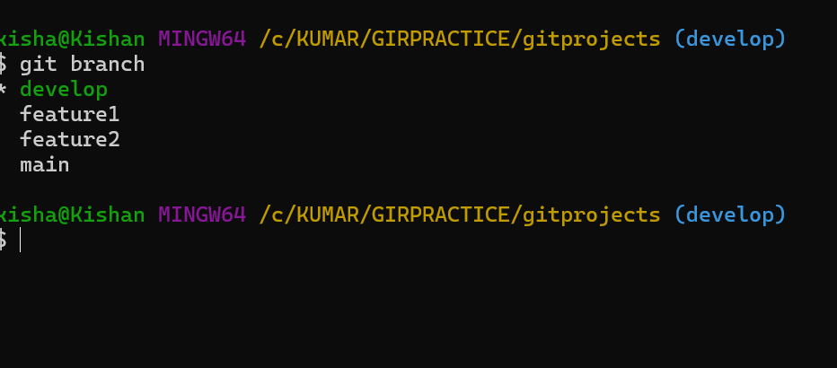

Commit main file in main branch

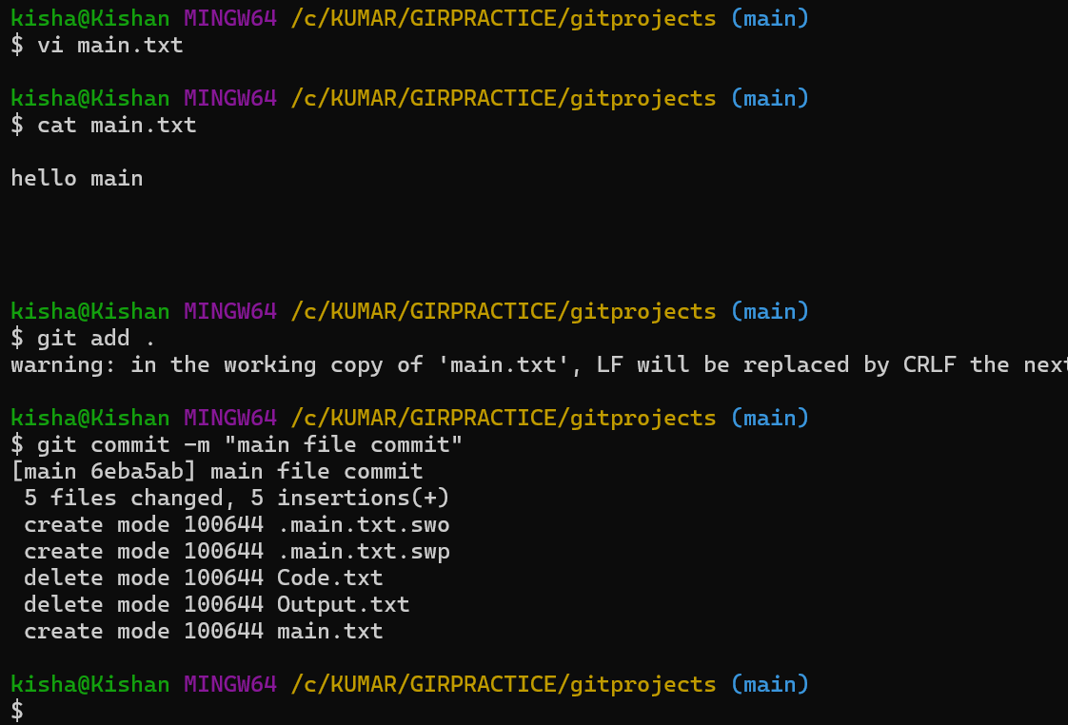

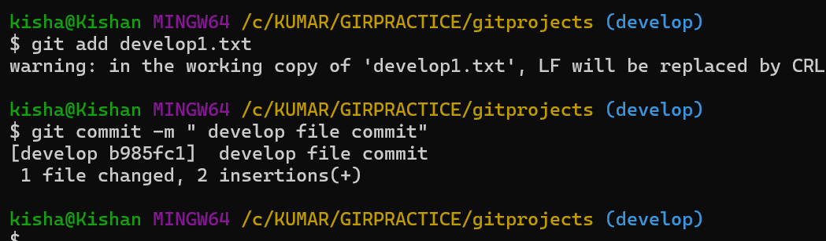

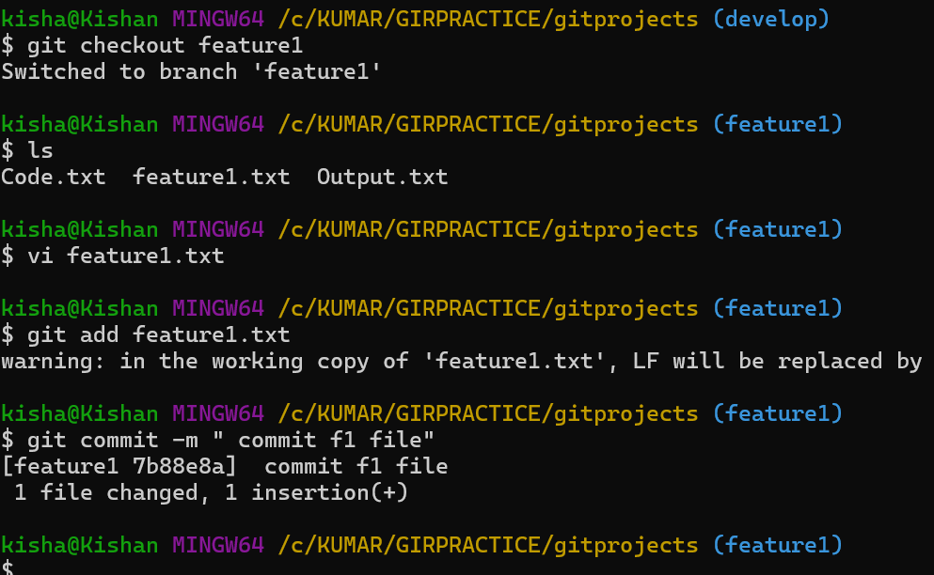

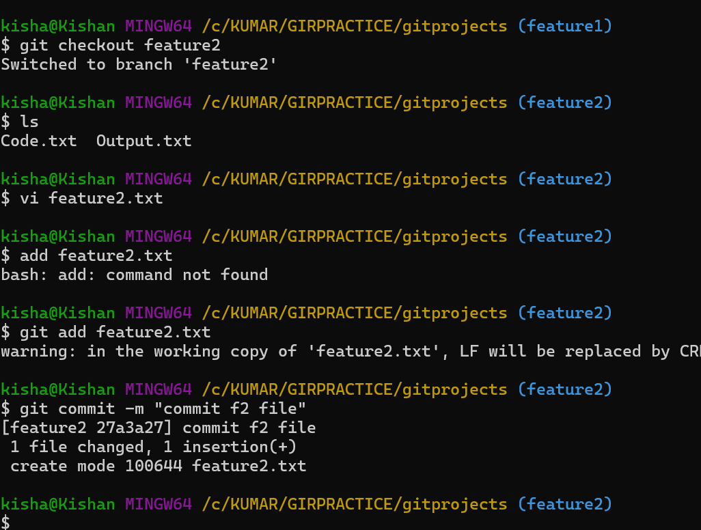

Pushing all changes into respective branches

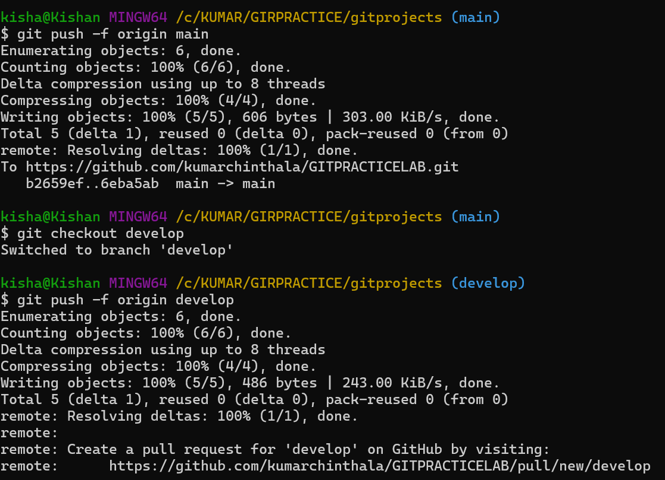

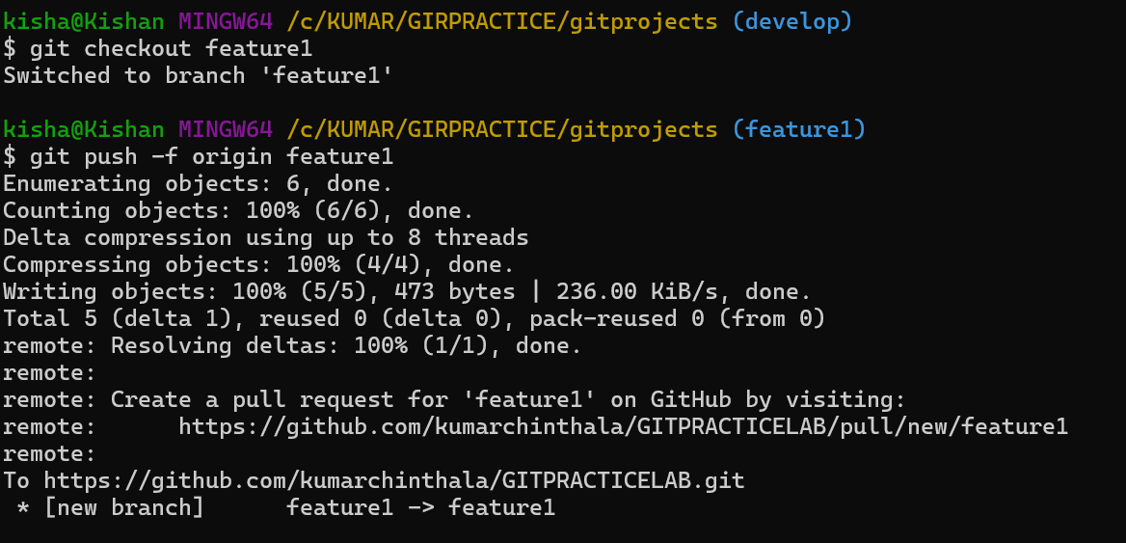

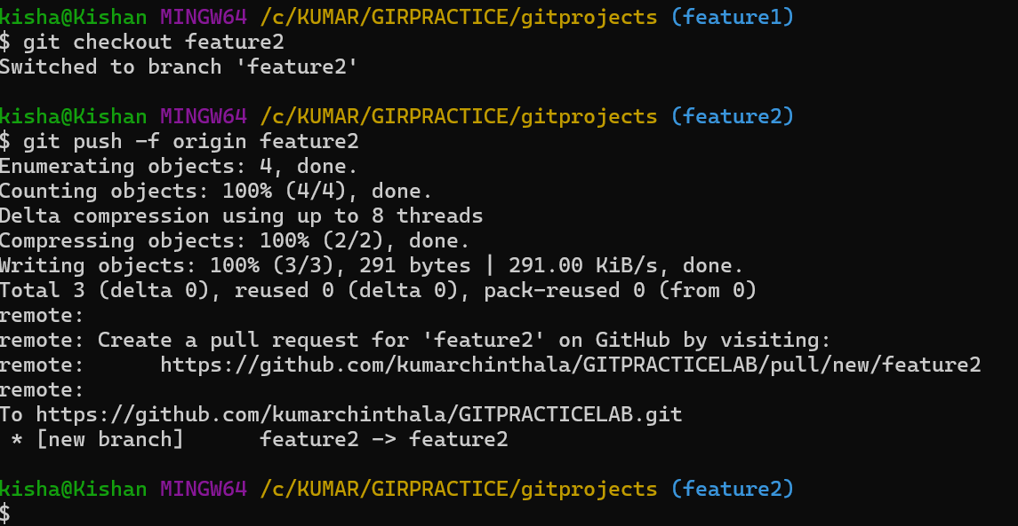

Delete Branch

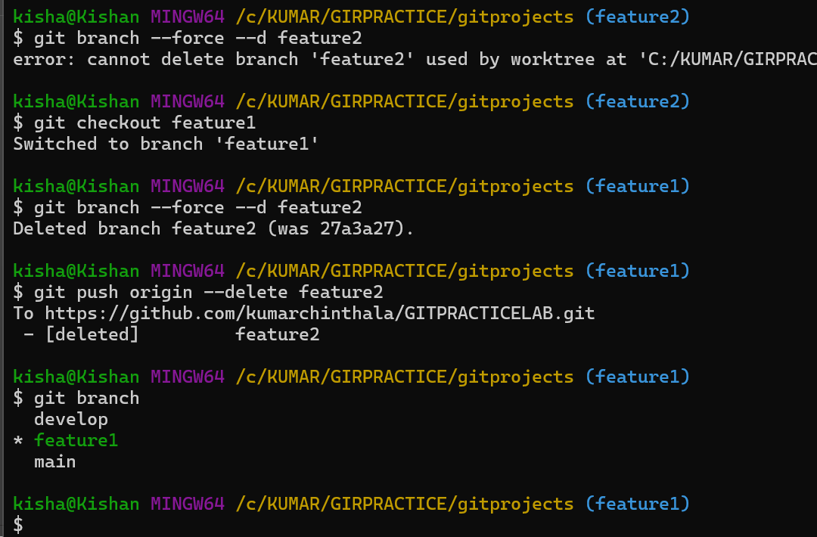

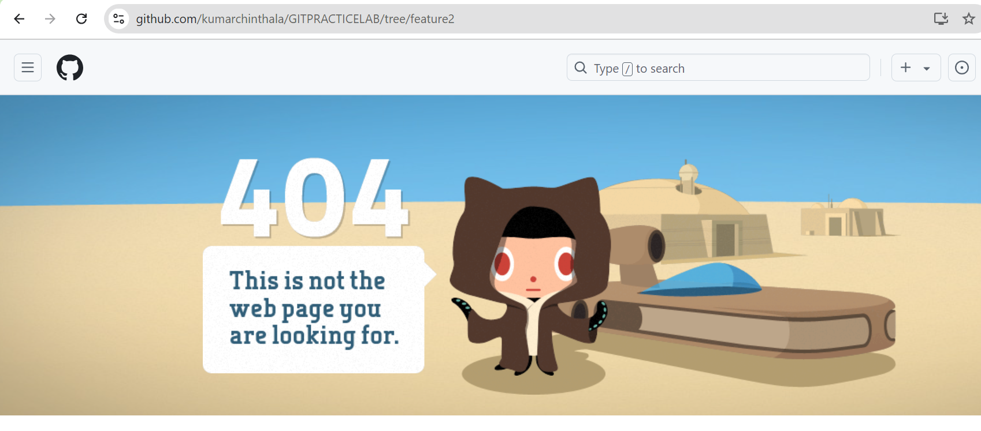

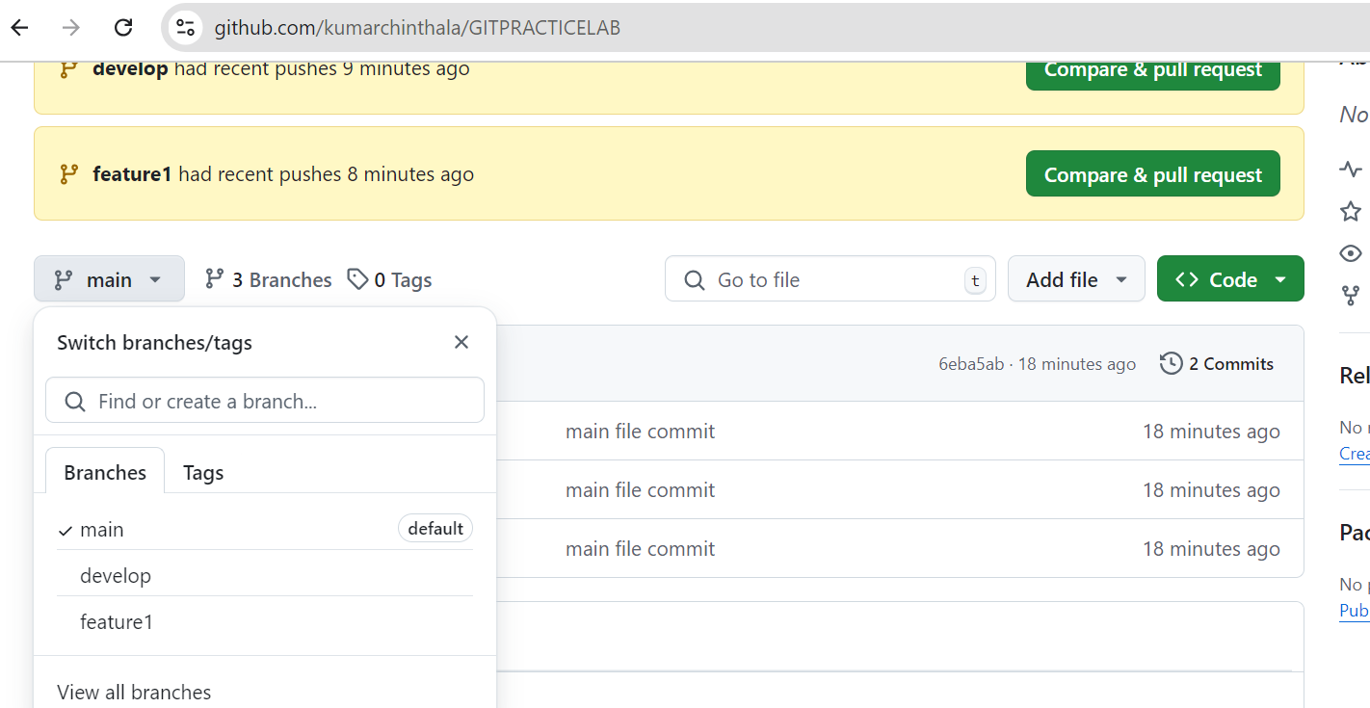

history

1 git config --global core.editor "vim"

2 vi main.txt

3 ls

4 ls

5 ls

6 git status

7 rm \*

8 rm -f \*

9 ls

10 vi main.txt

11 ls

12 cat main.txt

13 vi main.txt

14 cat main.txt

15 git add .

16 git commit -m "main file commit"

17 git checkout develop

18 ls

19 git add develop1.txt

20 git commit -m " develop file commit"

21 vit develop1.txt

22 vi develop1.txt

23 git add develop1.txt

24 git commit -m " develop file commit"

25 git checkout feature1

26 ls

27 vi feature1.txt

28 git add feature1.txt

29 git commit -m " commit f1 file"

30 git checkout feature2

31 ls

32 vi feature2.txt

33 add feature2.txt

34 git add feature2.txt

35 git commit -m "commit f2 file"

36 git checkout main

37 ls

38 git status

39 git push -f main

40 git push -f origin main

41 git checkout develop

42 git push -f origin develop

43 git checkout feature1

44 git push -f origin feature1

45 git checkout feature2

46 git push -f origin feature2

47 git rm feature2

48 git branch -d feature2

49 git branch -f -d feature2

50 git branch --force --d feature2

51 git checkout feature1

52 git branch --force --d feature2

53 git push origin --delete feature2

54 git branch

55 history